Purpose
Text based Generative AI tools (such as ChatGPT) have become increasingly popular due to their availability, ease of use and their ability to generate fast responses that are relevant, well-constructed and comprehensive.

There are clear productivity benefits to be gained through the use of these tools in a work setting. There are also risks which need to be considered.

At Wannon Water, we would like to encourage employees to experiment safely with two free versions of popular Generative AI tools – ChatGPT and CoPilot, specifically looking for productivity improvements.

Scope
These guidelines are for all Wannon Water employees.

Guidelines
This document provides an overview of some of the benefits and risks of these tools and guidance for their safe and effective use.

It should be read in conjunction with

- Records Management Procedure
- Information Technology Security Procedure

Opportunities

Productivity

One of the main benefits of using text based Generative AI tools in the workplace is that they can help companies save time and money. For example, ChatGPT can be used to generate reports, emails, and other documents, which can help employees complete their work more quickly and efficiently.
eg “Please write a procedure on the safe use of chainsaws”

Information Retrieval

You can ask a Generative AI tool for information about a subject (similar to the way you might use the Google search engine).
eg “How tall is the Eifel Tower”

Translation

It can translate from one language into another.
eg “How do I say thanks in Chinese”

Sentiment Analysis

A tool can assess whether a text message is positive, negative or neutral.
eg
Text: "I absolutely loved the movie! The plot was engaging, the characters were well-developed, and the ending was satisfying. Highly recommend!" Sentiment: Positive
This can be used to assess customer survey responses for example.

Scripting and coding

Most Generative AI tools can assist developers by providing sample code in popular languages.

Summarisation

Tools can summarise sections of text or even whole documents.

Recommendations

You can ask a tool to provide recommendations on work-related topics such as:
- Problem solving frameworks
- How to build a positive workplace culture
- Techniques to improve time management
- Creative approaches to problem solving
- etc

There’s much more! These are just some of the things that these tools can do. They are trained on such large datasets that they will usually have a response to most requests.

Risks and Limitations
While generative AI tools offer immense benefits, they also pose potential risks to data security, specifically through data loss, resulting in privacy impacts for customers, loss of Intellectual Property and reputational, regulatory, and legal risks for organisations.

Data security and privicy considerations

- Do not use sensitive or confidential information in your requests.

Once entered into these tools, the information has been effectively made available to the uncontrolled environment of the internet.

- Do not use any information that is owned or related to Wannon Water.

- Only ask general questions.

- Always adhere to Wannon Water’s data security and privacy procedures.

Limitations

Responses from Generative AI tools may also be limited as follows:

Data inaccuracy and biases

Generative AI models learn from the data they are trained on. If the data contains inaccuracies or biases, the model will learn and reproduce those inaccuracies or biases in its generated outputs. This can lead to the generation of misleading or incorrect information.

Lack of emotional intelligence

A Generative AI tool may misinterpret the emotional context of user input, leading to inappropriate or insensitive responses. They may also provide generic responses that do not resonate with users on an emotional level.

Limits on ability to reason

Reasoning helps in dealing with ambiguity and uncertainty. Without the ability to reason, generative AI tools may struggle when faced with ambiguous input or situations. This limitation can lead to inaccurate, contextually inappropriate, or nonsensical outputs, especially in real-world scenarios where information may be incomplete or ambiguous.

Mitigations

To address these limitations, check that the content produced has been fact checked and is accurate, current, appropriate, and sensitive.

Also, check that the content produced is in line with relevant procedures, policies, legislation and regulations.

It is also important to acknowledge the use of Generative AI within the creation of your content and in any resulting decision making. Generative AI can assist in making decisions – you remain the decision maker.

Effective Usage Guidelines
“Prompting” is a valuable skill in using Generative AI. It involves crafting questions or statements (prompts) in a way that guides the tool to produce desired outputs more effectively. This skill is crucial because the quality of the prompt will significantly influence the tool's response.

To use a Generative AI tool effectively, please consider the following usage guidelines:

- Be clear and specific and use normal language.
Provide clear and specific instructions to get more accurate and relevant responses.

- Prompt in different ways.
If the initial response is not what you are looking for, consider providing more context or rephrasing your prompt for better results.
If you dislike the response format, demonstrate the format you’d like to see.

- Split complex requests into several simpler requests.
You can have a “conversation” with a Generative AI tool, which comprises several sequential requests that are sometimes needed to get to an answer.
eg
Request 1: “how does ChatGPT work?”
Response 1: <<something too technical for your needs>>
Request 2: “please explain this as if I were 12 years old and limit the response to 5 lines”
Response 2: <<something easier to understand>>

Permitted tools
Wannon Water employees are currently permitted to use ChatGPT and Microsoft's CoPilot.

Using ChatGPT
There is a free version of ChatGPT that is accessible to the general public.

It can be accessed at: ChatGPT (openai.com)

You will then be prompted to create a login user account. Please use your Wannon Water email address for this.

Once you have signed on, you will see a page that looks like this:

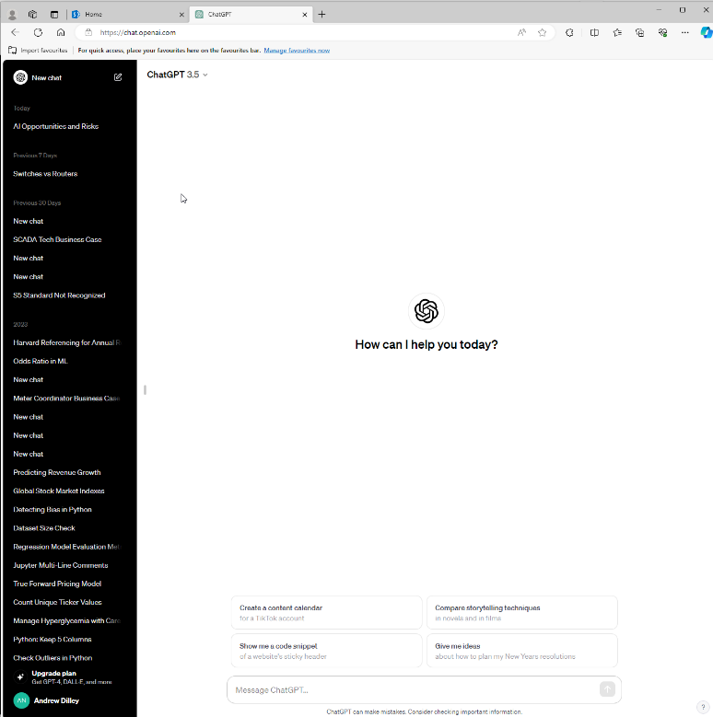

Using CoPilot
Microsoft's CoPilot is a new generative AI tool that is now available for free on the Edge browser on your PC. This version is called CoPilot with Bing Chat.

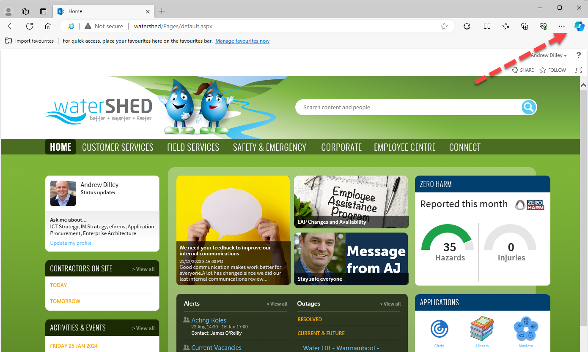

From here CoPilot can be used in a similar way to ChatGPT - generate text, answer questions, etc.
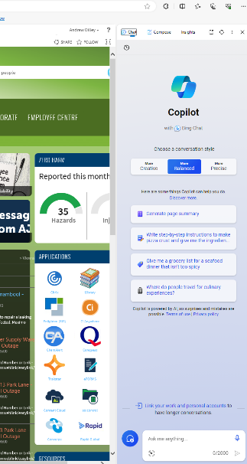

CoPilot will soon be available within the Microsoft Office suite of products (Word, Excel, Outlook, PowerPoint, Teams, SharePoint etc). When deployed at Wannon Water, you will be able to use CoPilot to perform other tasks that you currently do manually, such as document writing, email and report summarisation, minute taking in Teams and presentation generation.

Further information on this will be provided to employees in due course.

Next Steps

- Please experiment safely with ChatGPT and CoPilot
- A survey will be circulated to understand how you have been using these tools, and asking if you would like to participate in a Community of Interest which could help to drive the broader use of Generative AI in Wannon Water.

Assistance
All enquiries for assistance with the use of these tools should be directed through the Wannon Water IT Helpdesk.

Online resources
ChatGPT Tutorial - A Crash Course on Chat GPT for Beginners (youtube.com)
Copilot | Microsoft Edge

Roles and responsibilities
Position | Roles and responsibilities
All employees | To follow these guidelines

Definitions
Term | Means
Text-based Generative AI tools | Text-based Generative AI tools are advanced software applications that utilise natural language processing to autonomously create written content, such as articles, reports, or messages, without human intervention. These tools employ sophisticated algorithms to analyse and understand input data, generating coherent and contextually relevant text based on learned patterns. In a corporate context, these tools can enhance productivity by automating content creation tasks and streamlining communication processes.
ChatGPT | ChatGPT is a state-of-the-art, text-based generative AI model developed by OpenAI, designed for natural language understanding and generation in conversational contexts. It leverages deep learning techniques to respond contextually to user input, making it suitable for applications like chatbots, virtual assistants, and interactive dialogue systems. ChatGPT has been trained on diverse datasets to understand and generate human-like text, facilitating dynamic and interactive conversations.
Microsoft CoPilot | Microsoft CoPilot is an innovative text-based generative AI tool created by Microsoft and OpenAI, designed to assist users in various textual tasks by generating contextually relevant suggestions and responses. It employs advanced language models to understand input text and provide helpful content suggestions, making it valuable for a wide range of applications beyond coding, such as writing, brainstorming, and content creation. CoPilot aims to enhance user productivity by offering intelligent and context-aware text generation capabilities.

Governance
Parent policy/standard | N/A
Associated procedures/standards | Records Management Procedure  Information Technology Security Procedure
Relevant legislation | N/A
Approval | Chief Information Officer
Procedure owner | Chief Information Officer
Content enquiries | IT Helpdesk

Document version history
Version | Changes made to document
1 | New document

